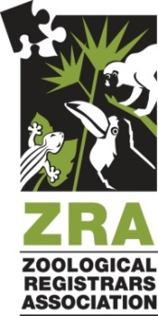
ZRA Annual Conference
Host Application Form

Thank you for your interest in hosting a ZRA Annual Conference. The continued success of this premier member event depends on the dedication and commitment of our host institutions

INSTITUTION INFORMATION
Name of Proposed Host Institution:
Must be a ZRA Institutional Member in good standing or shall agree to join as part of the Hosting Agreement).

Year Proposing to Host: 2021

Has your institution hosted a ZRA Annual Conference before?

Please attach a 1 to 2 page summary detailing special exhibits, collections or facilities that may be of interest to delegates and your institution's ability and financial commitment to host a ZRA Annual Conference.

Your recommendation for an Annual Conference Program Chairman will need to be attached and will require appointment by the ZRA Board of Directors along with the approval of your application.

SEND APPLICATION AND ATTACHMENTS TO:
Shelly Roach
Chairman, ZRA Annual Conference Committee
Columbus Zoo & Aquarium
9990 Riverside Dr. / PO Box 400.
Powell, OH 43065

Applications must be received no later than July 1 of the year previous to the year hosted but may be submitted sooner than that deadline. Once your application is received, you will be contacted by the Annual Conference Committee Chairman within seven (7) days to complete the application process. All applications received by July 1 will be reviewed and completed by August 1.

CONTACT INFORMATION
Proposed Host’s Name and Title:

Institution:

Address:

Phone: Email: Fax:

By submitting an application, you are indicating your interest in hosting a ZRA Annual Conference only, and are under no obligation until you review and complete the ZRA Annual Conference Hosting Agreement and the ZRA Board of Directors has approved you application.

Signature of CEO or Institutional Representative:

CEO or Institutional Representative’s Name & Title:

Date:

Declaration of Institutional Support for Application:

SUMMARY OF SPECIAL EXHIBITS, COLLECTIONS, ATTRACTIONS

